**Step 1: Create React App**

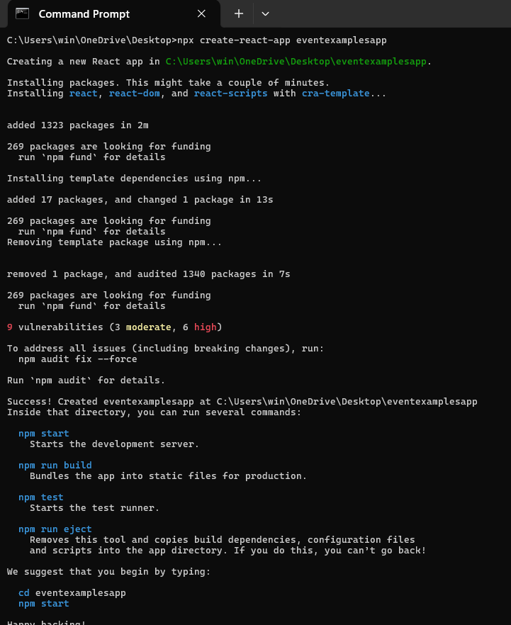

**Step 2: Create Counter with Increment & Decrement**

In src/Counter.js:

import React, { useState } from 'react';

function Counter() {

  const [count, setCount] = useState(0);

  const increment = () => {

    sayHello();

    setCount(count + 1);

  };

  const decrement = () => {

    setCount(count - 1);

  };

  const sayHello = () => {

    alert('Hello! Counter incremented!');

  };

  return (

    <div>

      <h2>Counter: {count}</h2>

      <button onClick={increment}>Increment</button>

      <button onClick={decrement}>Decrement</button>

    </div>

  );

}

export default Counter;

### ****Step 3: Create Say Welcome Button with Argument****

**In src/SayWelcome.js:**

import React from 'react';

function SayWelcome() {

  const greet = (message) => {

    alert(message);

  };

  return (

    <button onClick={() => greet('Welcome!')}>

      Say Welcome

    </button>

  );

}

export default SayWelcome;

### ****Step 4: Handle Synthetic Event****

**In src/SyntheticEvent.js:**

import React from 'react';

function SyntheticEvent() {

  const handleClick = (e) => {

    e.preventDefault();

    alert('I was clicked');

  };

  return (

    <button onClick={handleClick}>

      OnPress

    </button>

  );

}

export default SyntheticEvent;

### ****Step 5: Create CurrencyConvertor (INR to Euro)****

**In src/CurrencyConvertor.js:**

import React, { useState } from 'react';

function CurrencyConvertor() {

  const [rupees, setRupees] = useState('');

  const [euros, setEuros] = useState('');

  const handleSubmit = (e) => {

    e.preventDefault();

    const result = parseFloat(rupees) / 90; // example conversion rate

    setEuros(result.toFixed(2));

  };

  return (

    <div>

      <h3>Currency Convertor</h3>

      <form onSubmit={handleSubmit}>

        <input

          type="number"

          placeholder="Enter amount in INR"

          value={rupees}

          onChange={(e) => setRupees(e.target.value)}

        />

        <button type="submit">Convert</button>

      </form>

      {euros && <p>Euros: €{euros}</p>}

    </div>

  );

}

export default CurrencyConvertor;

### ****Step 6: Import Components in App****

**In src/App.js:**

import React from 'react';

import Counter from './Counter';

import SayWelcome from './SayWelcome';

import SyntheticEvent from './SyntheticEvent';

import CurrencyConvertor from './CurrencyConvertor';

function App() {

  return (

    <div className="App">

      <h1>React Events Hands-On Lab</h1>

      <Counter />

      <SayWelcome />

      <SyntheticEvent />

      <CurrencyConvertor />

    </div>

  );

}

export default App;

### ****Step 7: Run the Project****

### 

### ****Step 8: Output****

### 

### 